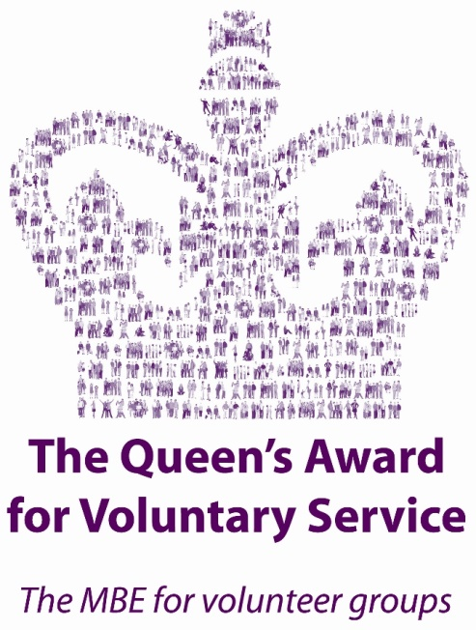

Volunteering for Icebreakers

As Icebreakers is run by a team of trained, dedicated volunteers without any paid staff. We are welcoming of anyone interested in volunteering with us. Icebreakers aims to be an excellent equal opportunities group and we wish to attract the best candidate volunteers from all sections of the community. We aim to ensure that all volunteers are recruited on the basis of actual and potential ability and personal skills.
Icebreakers needs its volunteers to be able to fulfil at least our minimum time commitment of:
- 2 Wednesday evenings per month (facilitating the group sessions);
- 1 Thursday evening per month (a volunteer meeting the third Thursday each month);
- 1 morning, afternoon or evening per year to run a social event (usually in the last weekend of a month).

Also, to take up a role in the running of the volunteer team such as administration, data entry, simple website maintenance, e-mail account management, basic financial account recording.
We are looking for men who are reliable, enthusiastic, capable, and committed to helping us continue to provide a high level of service to our group-users.
Please complete the application form below if you are:
- a gay or bisexual man, aged at least 18 years old, who presents as male;
- able to commit to our minimum time requirement (detailed above), and
- happy to submit to a Disclosure and Barring Service check.
We will invite you to attend one of our Wednesday night client group meetings so that you can observe how the group functions and ask any questions that you might have. If you are happy to continue then we will invite you on to our training programme and assign a ‘buddy’ who will guide you on your journey to becoming a fully trained volunteer and whom you can contact whenever you feel the need.
Training lasts a few months and involves attending the Wednesday night sessions and participating in ‘on-the-job’ training by the volunteers on duty. Once you have mastered all the necessary aspects of the role to the satisfaction of the other volunteers, you will join the award-winning team as a fully-fledged Icebreakers Volunteer.
If you cannot commit as much time as we are asking, but you have skills that you think we can use, please consider offering to help ‘behind the scenes’. Helpful skills would be administration, data entry, simple website maintenance, e-mail account management, basic financial account recording, or any skills in publicising or promoting the group to potential new users or volunteers.

Volunteer Application Form

This form should be used by any gay or bisexual man wishing to volunteer at Icebreakers.
If you are having difficulties completing this form for any reason then please contact us via
info@icebreakersmanchester.org.uk. We will endeavour to get back to you within a week.

All completed forms must be submitted either via info@icebreakersmanchester.org.uk or posted to:
Icebreakers’ Chairman
c/o LGBT Foundation Community Resource Centre,
Number 5 Richmond Street,
Manchester, M1 3HF

Thank you for completing this form.
The Icebreakers Volunteer Team.

PERSONAL DETAILS

Full Name

Address

Post Code:

Phone Number(s)
Evening:

Daytime:

E-mail Address:

Date of Birth:

APPLICATION QUESTIONS

If you need more space to write your answers, please continue over the page and clearly mark to which question your answer relates.

Are you a gay or bisexual man, aged 18 or over, who presents as male? | YES / NO
Can you commit to our minimum requirements? | YES / NO
Are you happy to have a DBS check? | YES / NO
If you have answered ‘NO’ to any of the questions above are you applying to offer your skills ‘behind- the- scenes’? | YES / NO

Have you attended Icebreakers yourself as a group user? If so, when and what was your experience like?
What (if any) has been your previous experience of volunteering?
What skills and expertise do you feel you can bring to Icebreakers?
What are your hobbies and interests?
Please tell us about yourself.
(You can mention what you are doing at the moment, why you want to volunteer, or any information that you might think is relevant.)
Version 2 2016

DBS checks are mandatory as some of our group users can be classed as Vulnerable Adults.

